**Vidit Doshi**

**Roll no. J012, J1 Batch**

**Practical 2: Keras Initializations**

**Aim:** To understand the various types of initializers available in Keras.

**Observations:**

1. Baseline model on CIFAR10 Dataset accuracy : 0.3944
2. Model with initializer as Random Uniform and zero accuracy: 0.5220
3. Model with weights as ones accuracy: 0.1000
4. Model initialized with constant values accuracy: 0.1000
5. Random Normal init. model accuracy: 0.5215
6. RandomUniform init. model accuracy: 0.5162
7. TruncatedNormal init. model accuracy: 0.5027
8. Variancescaling init. model accuracy: 0.5160
9. Orthogonal model init. accuracy: 0.1000
10. Identity model init. accuracy: 0.2623
11. Lecun_uniform init. model accuracy: 0.5137
12. Glorot_normal init. model accuracy: 0.5113
13. Glorot_uniform init. model accuracy: 0.5187
14. He_normal model init. accuracy: 0.5139
15. Lecun_normal model init. accuracy: 0.5090
16. He_uniform model init. accuracy: 0.5119

**Model on CIFAR10 dataset with random_normal init. And 4 layers:**

Model Summary:

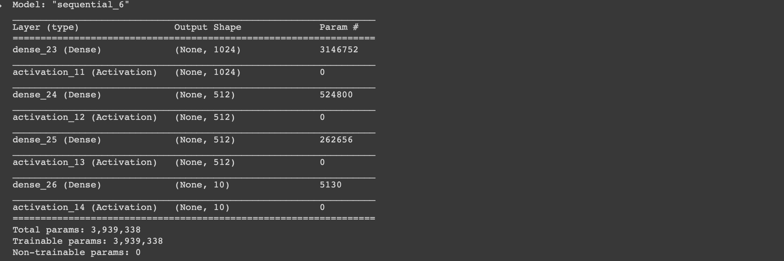

Model Accuracy: 0.5090